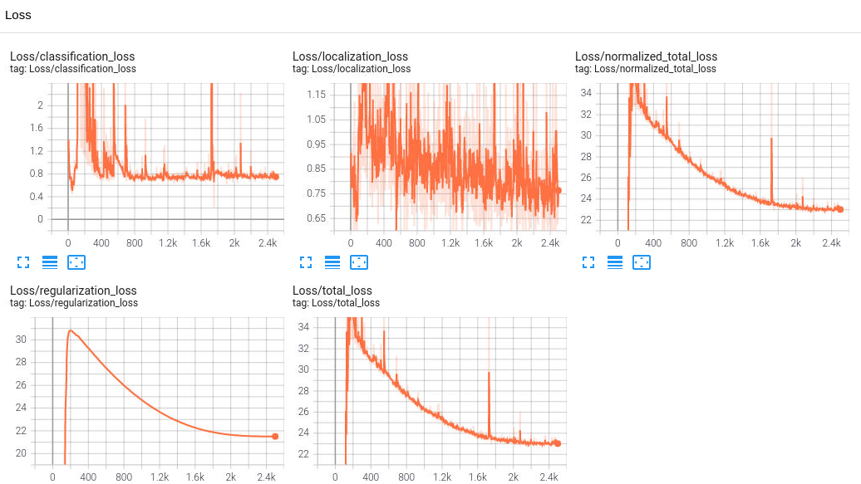

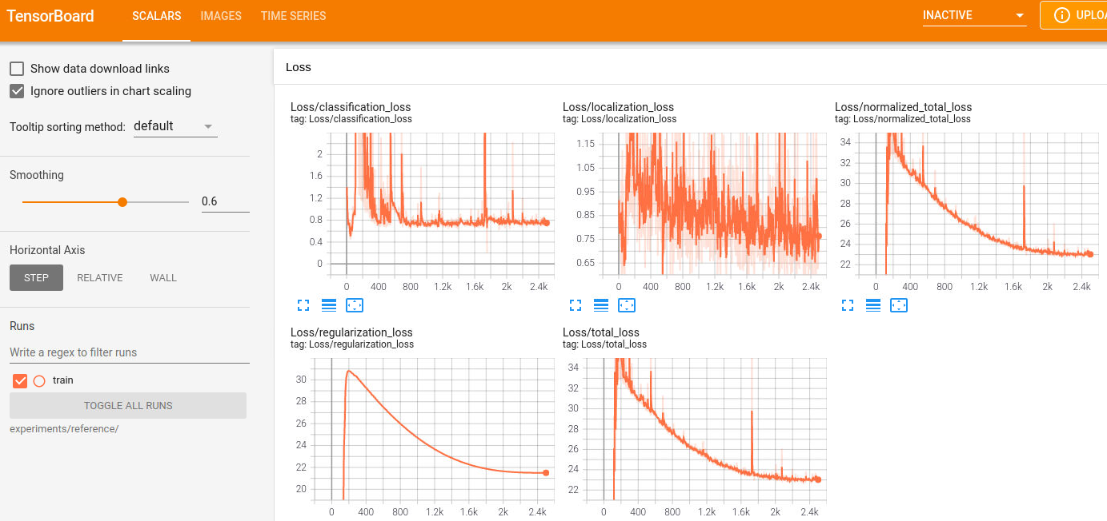

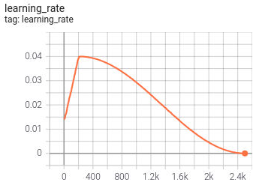

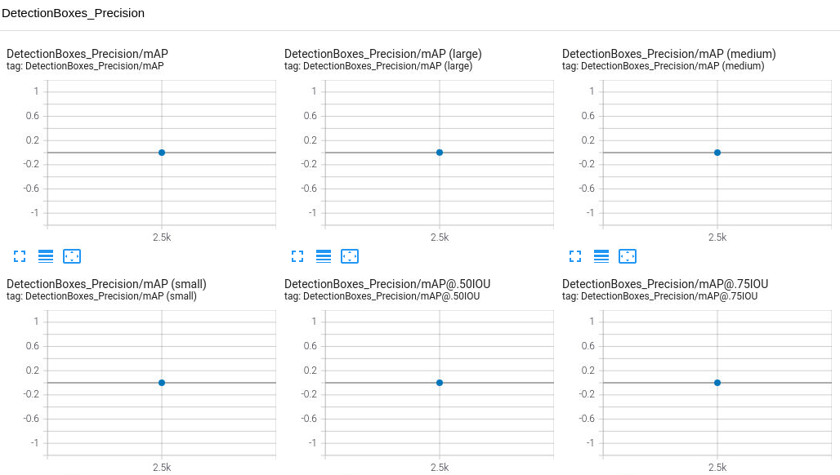

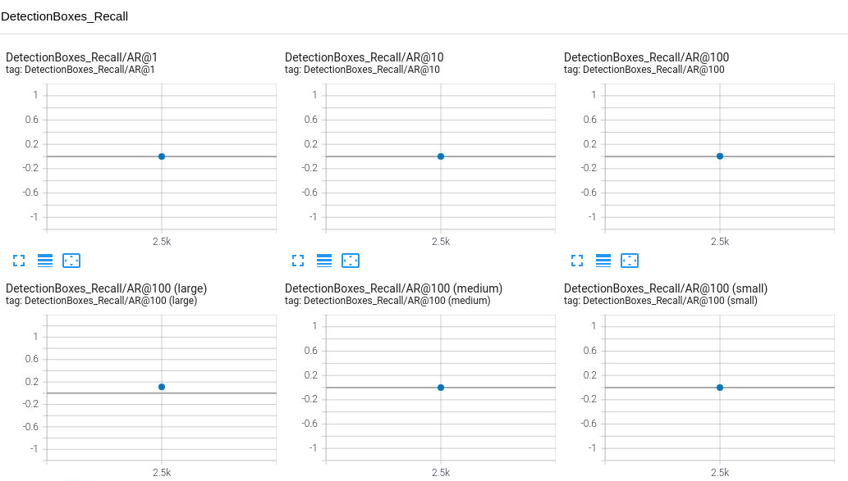

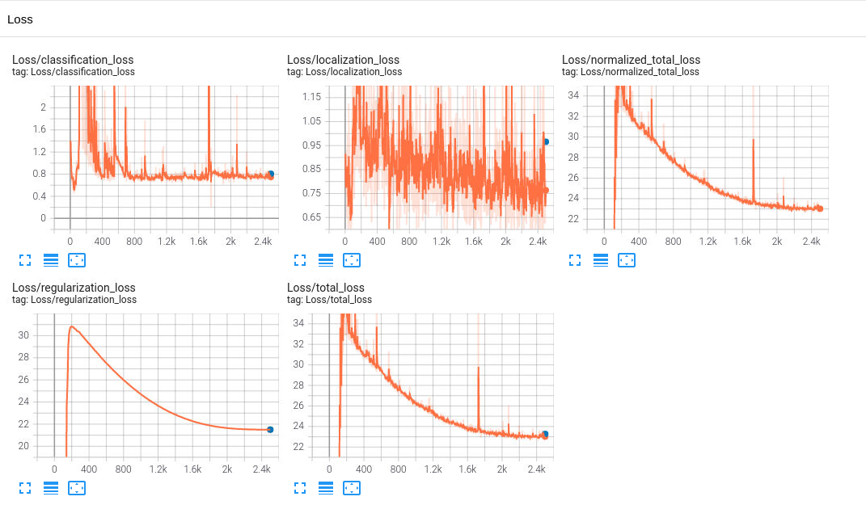

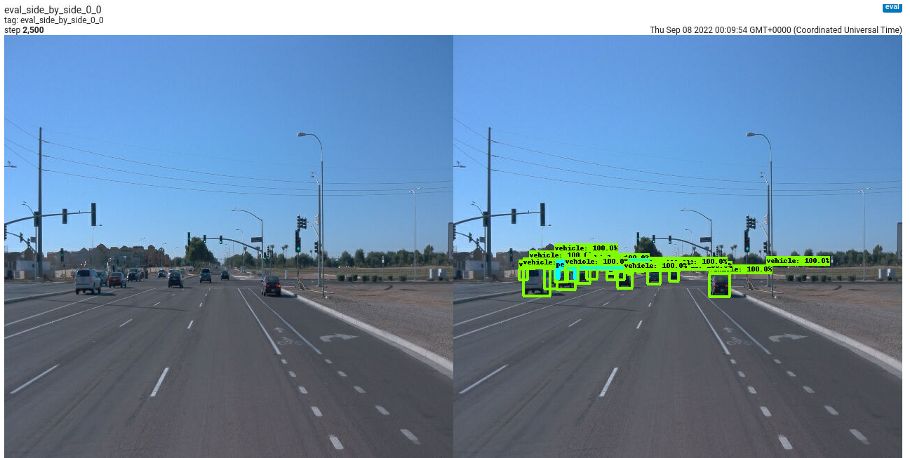

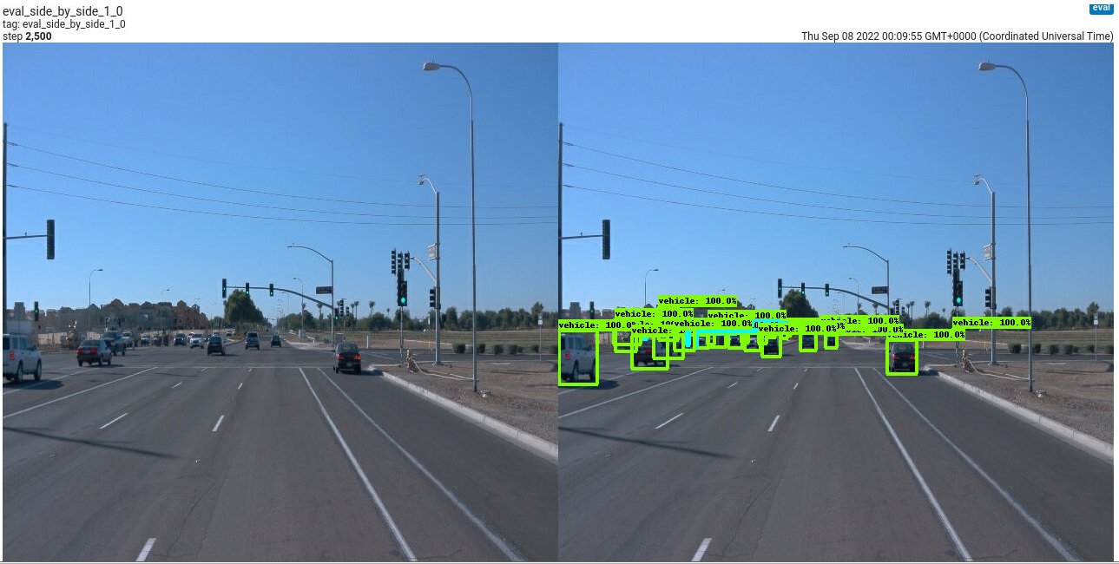

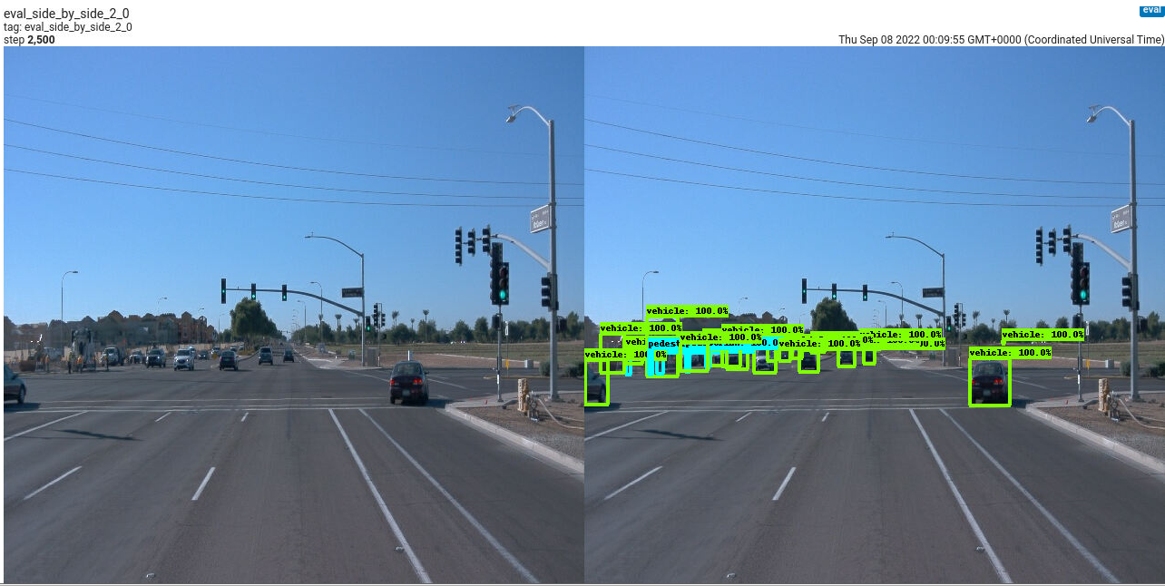

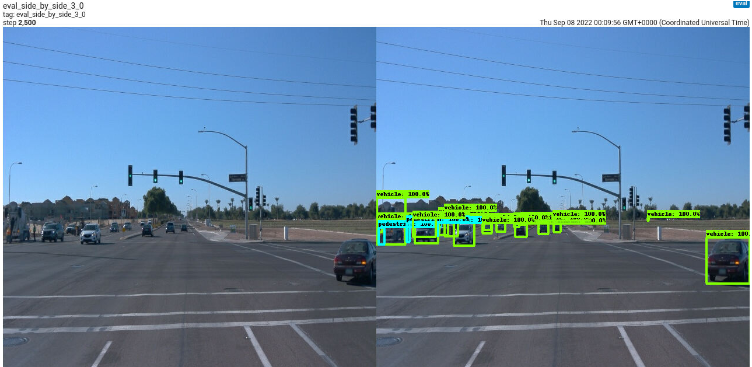

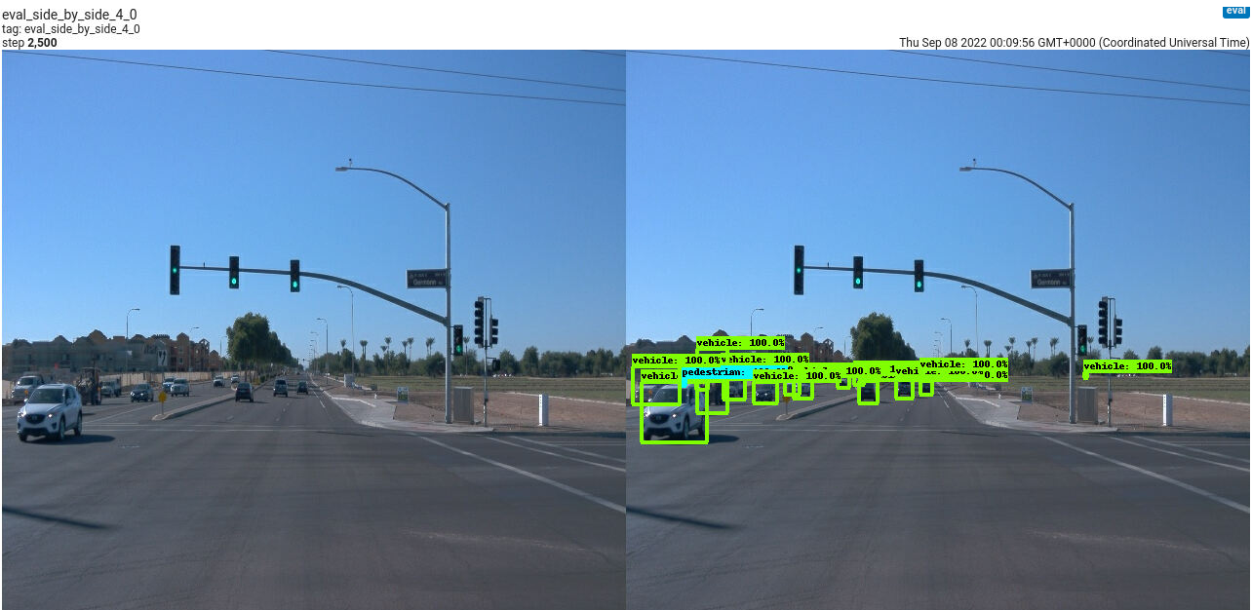

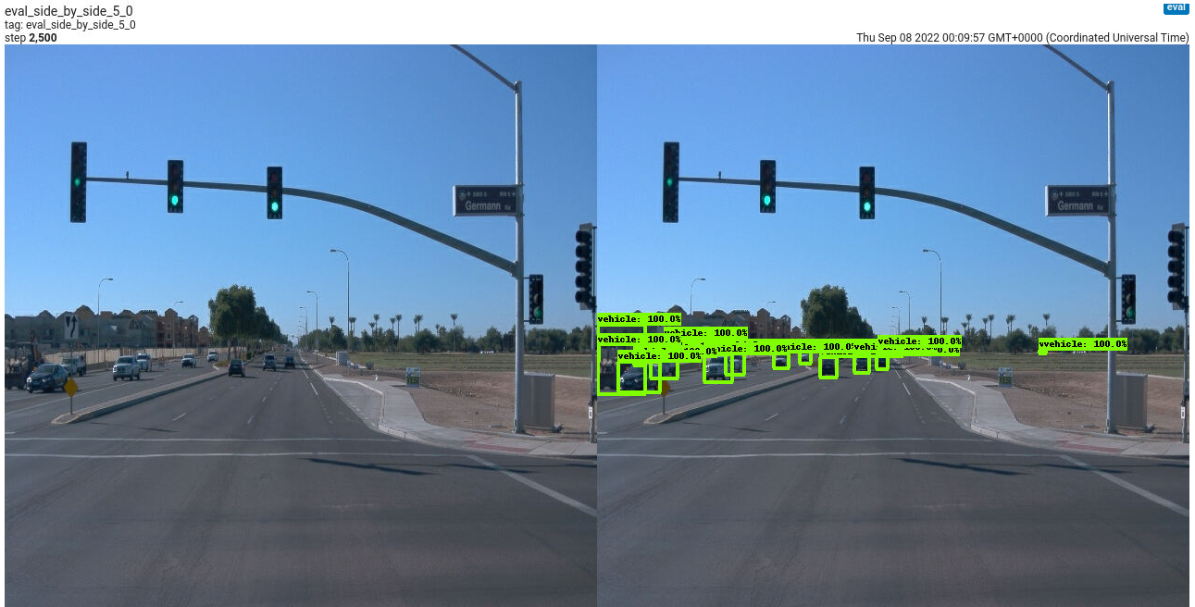

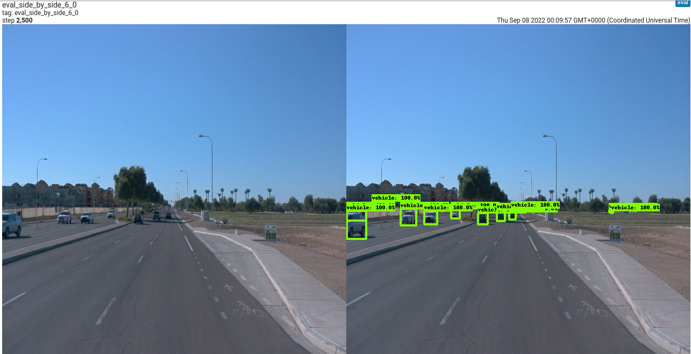

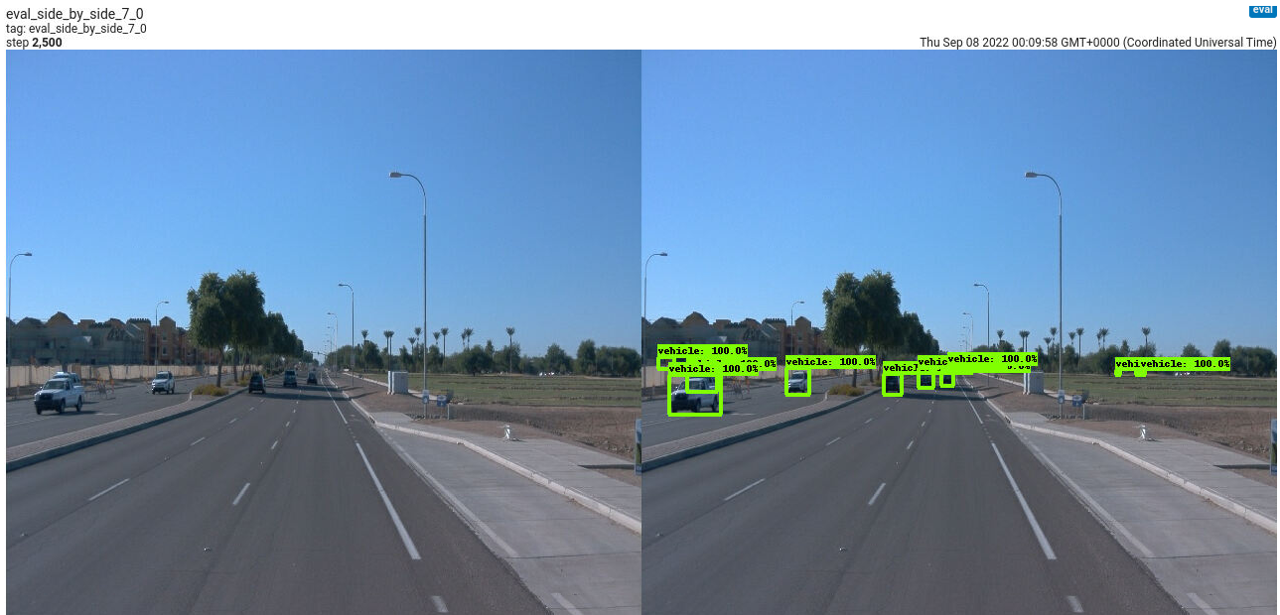

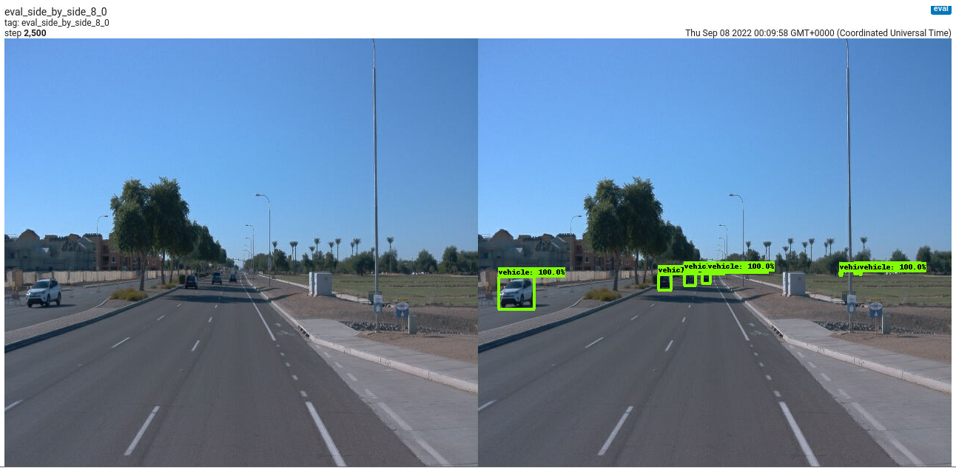

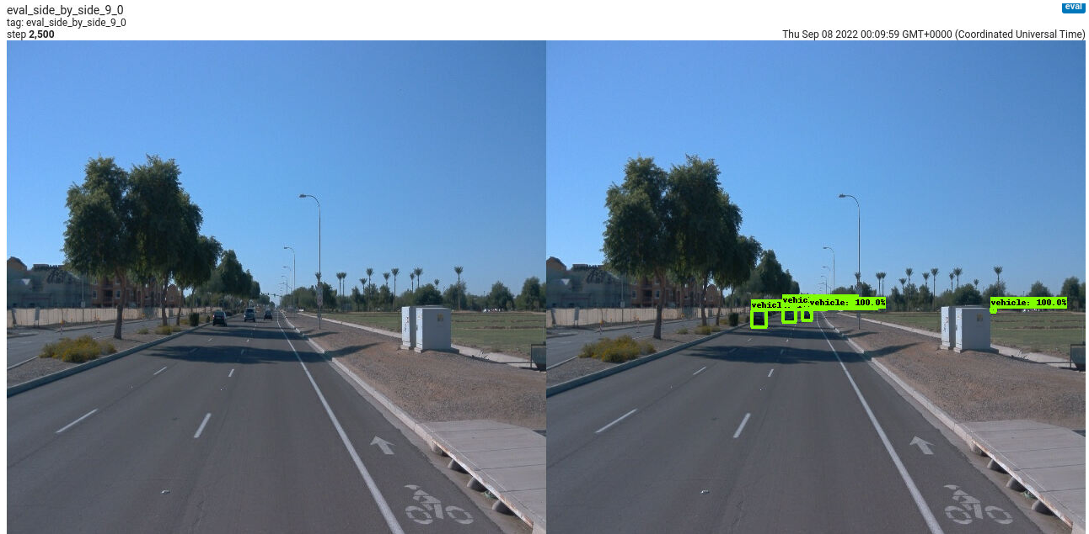

ONE (t=0.30s).

Average Precision (AP) @[ IoU=0.50:0.95 | area= all | maxDets=100 ] = 0.000

Average Precision (AP) @[ IoU=0.50 | area= all | maxDets=100 ] = 0.001

Average Precision (AP) @[ IoU=0.75 | area= all | maxDets=100 ] = 0.000

Average Precision (AP) @[ IoU=0.50:0.95 | area= small | maxDets=100 ] = 0.000

Average Precision (AP) @[ IoU=0.50:0.95 | area=medium | maxDets=100 ] = 0.000

Average Precision (AP) @[ IoU=0.50:0.95 | area= large | maxDets=100 ] = 0.002

Average Recall (AR) @[ IoU=0.50:0.95 | area= all | maxDets= 1 ] = 0.000

Average Recall (AR) @[ IoU=0.50:0.95 | area= all | maxDets= 10 ] = 0.001

Average Recall (AR) @[ IoU=0.50:0.95 | area= all | maxDets=100 ] = 0.006

Average Recall (AR) @[ IoU=0.50:0.95 | area= small | maxDets=100 ] = 0.000

Average Recall (AR) @[ IoU=0.50:0.95 | area=medium | maxDets=100 ] = 0.001

Average Recall (AR) @[ IoU=0.50:0.95 | area= large | maxDets=100 ] = 0.112

INFO:tensorflow:Eval metrics at step 2500

I0908 00:11:00.532340 139918461306624 model_lib_v2.py:988] Eval metrics at step 2500

INFO:tensorflow: + DetectionBoxes_Precision/mAP: 0.000161

I0908 00:11:00.540560 139918461306624 model_lib_v2.py:991] + DetectionBoxes_Precision/mAP: 0.000161

INFO:tensorflow: + DetectionBoxes_Precision/mAP@.50IOU: 0.000621

I0908 00:11:00.542182 139918461306624 model_lib_v2.py:991] + DetectionBoxes_Precision/mAP@.50IOU: 0.000621

INFO:tensorflow: + DetectionBoxes_Precision/mAP@.75IOU: 0.000056

I0908 00:11:00.543757 139918461306624 model_lib_v2.py:991] + DetectionBoxes_Precision/mAP@.75IOU: 0.000056

INFO:tensorflow: + DetectionBoxes_Precision/mAP (small): 0.000000

I0908 00:11:00.545506 139918461306624 model_lib_v2.py:991] + DetectionBoxes_Precision/mAP (small): 0.000000

INFO:tensorflow: + DetectionBoxes_Precision/mAP (medium): 0.000059

I0908 00:11:00.547295 139918461306624 model_lib_v2.py:991] + DetectionBoxes_Precision/mAP (medium): 0.000059

INFO:tensorflow: + DetectionBoxes_Precision/mAP (large): 0.002436

I0908 00:11:00.549081 139918461306624 model_lib_v2.py:991] + DetectionBoxes_Precision/mAP (large): 0.002436

INFO:tensorflow: + DetectionBoxes_Recall/AR@1: 0.000130

I0908 00:11:00.550566 139918461306624 model_lib_v2.py:991] + DetectionBoxes_Recall/AR@1: 0.000130

INFO:tensorflow: + DetectionBoxes_Recall/AR@10: 0.000998

I0908 00:11:00.552044 139918461306624 model_lib_v2.py:991] + DetectionBoxes_Recall/AR@10: 0.000998

INFO:tensorflow: + DetectionBoxes_Recall/AR@100: 0.005670

I0908 00:11:00.553537 139918461306624 model_lib_v2.py:991] + DetectionBoxes_Recall/AR@100: 0.005670

INFO:tensorflow: + DetectionBoxes_Recall/AR@100 (small): 0.000000

I0908 00:11:00.554841 139918461306624 model_lib_v2.py:991] + DetectionBoxes_Recall/AR@100 (small): 0.000000

INFO:tensorflow: + DetectionBoxes_Recall/AR@100 (medium): 0.000522

I0908 00:11:00.556238 139918461306624 model_lib_v2.py:991] + DetectionBoxes_Recall/AR@100 (medium): 0.000522

INFO:tensorflow: + DetectionBoxes_Recall/AR@100 (large): 0.112200

I0908 00:11:00.557663 139918461306624 model_lib_v2.py:991] + DetectionBoxes_Recall/AR@100 (large): 0.112200

INFO:tensorflow: + Loss/localization_loss: 0.965827

I0908 00:11:00.558993 139918461306624 model_lib_v2.py:991] + Loss/localization_loss: 0.965827

INFO:tensorflow: + Loss/classification_loss: 0.807156

I0908 00:11:00.560219 139918461306624 model_lib_v2.py:991] + Loss/classification_loss: 0.807156

INFO:tensorflow: + Loss/regularization_loss: 21.504168

I0908 00:11:00.561533 139918461306624 model_lib_v2.py:991] + Loss/regularization_loss: 21.504168

INFO:tensorflow: + Loss/total_loss: 23.277147

I0908 00:11:00.562854 139918461306624 model_lib_v2.py:991] + Loss/total_loss: 23.277147